# KENDRIYA VIDYALAYA HBK NO.2 DEHRADUN

# **MID TERM EXAMINATION 2022-2023**

**Sub:EVS Max Marks:40**

**Class: V Time 1 ½ hrs.**

**Name: Section:**

**Roll No. Date:**

**Sign of the invigilator Sign of the examiner** _

|  |  |  |  |  |
| --- | --- | --- | --- | --- |
| Competency | Observation & recording | Identification &  classification | Discovering facts | Overall |
| Marks | 10 | 15 | 15 | 40 |

## OBSERVATION AND REPORTING

**VSA** 1x6= 6

**Q1(A)** Look at the following pictures and write its name or activity.

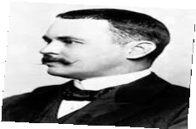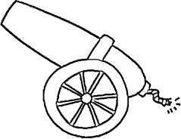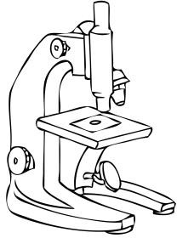

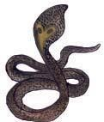

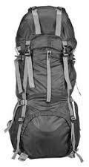

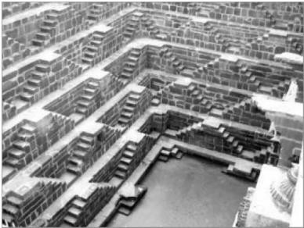

Q 1 (B) Fill in the blanks with proper word.1x4 = 4

1. Ants have super sense of (Smell,hearing)
2. Golconda fort is located in .(Kerala, Hyderabad) 3. Bread spoils faster in season. (Winter, Rainy)

4. Jim Corbett National Park is situated in state.

## IDENTIFICATION AND CLASSIFICATION VSA 1x5 =5

1. **Answer in one sentence .**
   1. Nehru institute of mountaineering is situated in which state ?

Ans :

* 1. What is the height of Mount Everest ?

Ans :

* 1. In which season Malaria is more common?

Ans :

* 1. What are the young ones of mosquitoes called ?

Ans :

* 1. Who lead the Dandi March ?

Ans :

**SA 2X3= 6**

1. 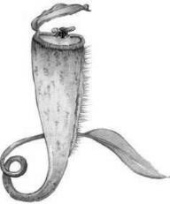Identify this plant. Write about its special feature.

Ans :

1. Name four agents of seed dispersal.

Ans :

1. Mark ( ) the things whether it floats or sinks :

|  |  |  |
| --- | --- | --- |
| **Things** | **float** | **sink** |
| Iron nail |  |  |
| Match-stick |  |  |
| Coin |  |  |
| Empty plastic bottle |  |  |

**LA** 1x4=4

Q.1. What all things were there in the Rucksack?

Ans. ______________________________________________________________________________________________________________________________________________________________________________________________________________________________________________________________________________________________________________________________________________________________________________________________________________________________

## DISCOVERY OF FACTS

VSA 1x5 =5

1. Answer the following:
   1. What is the normal range of a healthy female’s haemoglobin?

Ans :

* 1. Who is the first Indian woman to reach Mount Everest?

Ans :

* 1. What are the young ones of the mosquitoes called ?

Ans :

* 1. What grow on a wet bread if kept for many days ?

Ans :

* 1. Name any two poisonous snakes found in India.

Ans :

**SA 2x3**

1. Which of the following are soluble and insoluble in water . ( Salt, sugar, stones, nail)

Ans : Soluble Insoluble

1. Which things are made from ripe and unripe mangoes?

Ans:

1. Why snake is called farmers’ friend ?

Ans:

**LA 1x4= 4**

Q.1. Look at the map of given fort carefully and answer the questions.

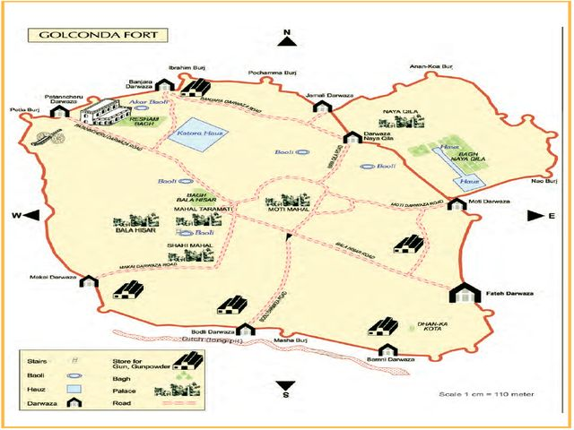

1 . Which fort is shown in the map ?

Ans : 2.What is scale taken in the map ?

Ans : 3.How many doors (Darwaza) can be seen on fort wall ?

Ans : 4.How many stores for gun and gun powder can be seen in the map ?

Ans : __________________________________________________________